2A - Feature Representation
We replaced the Bag-of-Words representation used in Problem 1 with contextual BERT embeddings provided by the assignment dataset.
Each passage is represented by a dense vector of {{768}} dimensions, pre-computed using a transformer model trained on large-scale English corpora.
These embeddings encode semantic and syntactic context, allowing the classifier to recognize similar meanings expressed with different wording.

Training data: x_train_BERT_embeddings.npz → shape (5557, 768)
Test data: x_test_BERT_embeddings.npz → shape (1197, 768)
Labels come from y_train.csv, mapping Key Stage 2–3 → 0 and Key Stage 4–5 → 1.

The vectors were loaded with a custom load_arr_from_npz() function that ensures alignment with x_train.csv.
No additional normalization or feature concatenation was applied in this baseline, although future extensions could append readability and sentiment metrics from x_train.csv for feature fusion.

2B - Cross-Validation Design
To evaluate and select the best classifier configuration, we used a {{K}}-fold StratifiedGroupKFold cross-validation procedure with author-level grouping.
The evaluation metric was the Area Under the ROC Curve (AUROC), chosen because it is threshold-independent and matches the leaderboard metric.
We performed hyperparameter tuning via GridSearchCV, which exhaustively searched across the specified parameter grid and automatically refit the best model on the full training data.
All models were trained exclusively on the provided x_train.csv and y_train.csv data; test data were used only for final leaderboard prediction.

2C - Classifier and Hyperparameter Search
We evaluated three classifiers on the 768-dimensional BERT embeddings: Logistic Regression, Linear SVM, and a Multi-Layer Perceptron (MLP).
Each model was tuned using GridSearchCV with 5-fold StratifiedGroupKFold cross-validation and AUROC scoring.
The following hyperparameter grids were explored:

Logistic Regression regularization strength C {0.0001, 0.001, 0.01, 0.1, 1, 3, 10, 30, 50} and L1-L2 penalties
Linear SVM with Margin regularization C {0.0001, 0.001, 0.01, 0.1, 1, 3, 10, 30, 50}
MLP Neural Network hidden_layer_sizes {(64,64), (64,128), (128,64), (128,128), (128,256), (256,256)} and alpha {1e-5, 1e-4, 1e-3, 1e-2}

Overall, Logistic regression kept showing the best results. To optimize the Logistic Regression classifier, we performed a grid search over the regularization parameter C, which controls model complexity.
In LR, small values of C enforce strong regularization, limiting overfitting by constraining the magnitude of learned coefficients, while larger values reduce regularization and allow more flexible decision boundaries.
The chosen grid spanned twelve logarithmically spaced values from 1e−6 to 100, covering both extreme underfitting (left side) and overfitting (right side) regimes.
Each configuration was evaluated using 5-fold StratifiedGroupKFold cross-validation with AUROC as the scoring metric.
The grid was designed wide enough to find the U shape that is desired in finding a model that generalizes best.
No convergence or step-size issues were observed because the liblinear solver handles small datasets and sparse features efficiently, and the search was limited to a reasonable number of folds and regularization settings.

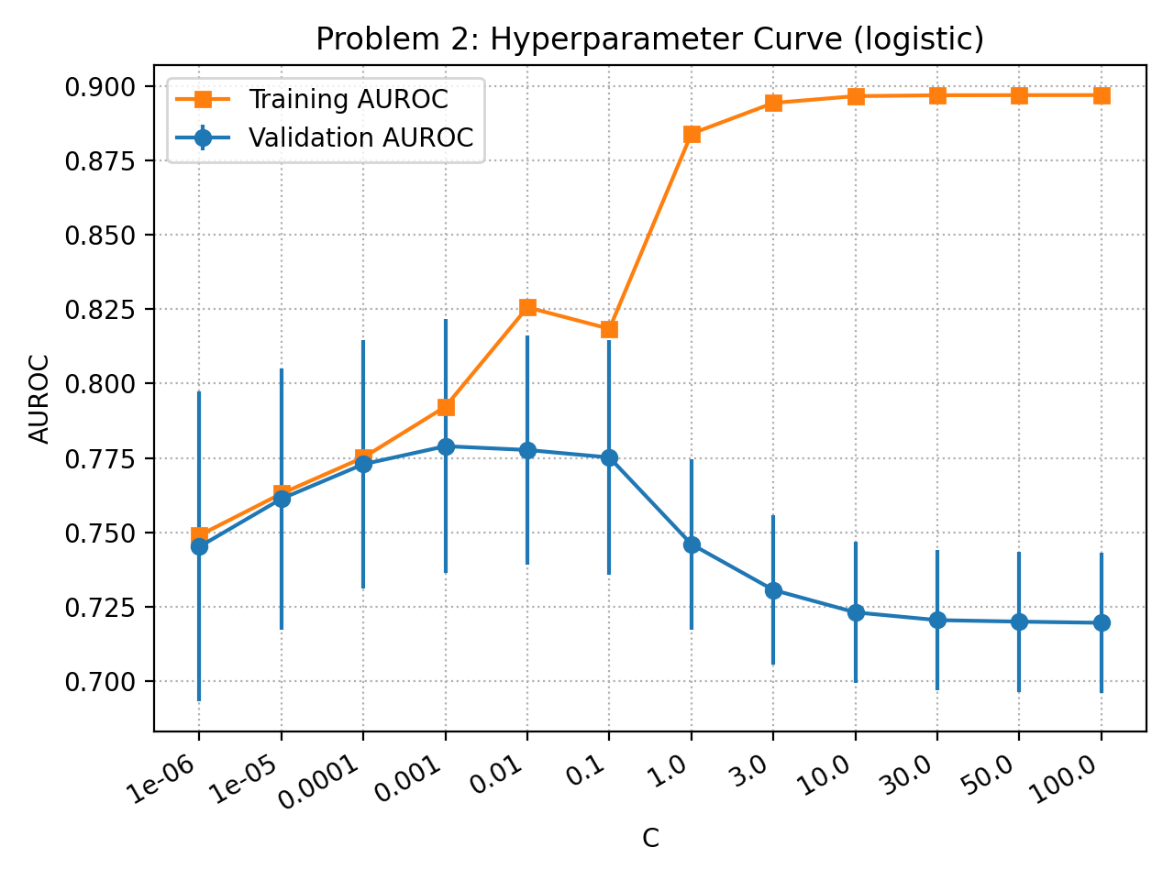Figure 1: Training (orange) and validation (blue) AUROC as a function of the regularization parameter C.
Validation performance peaks around C = 0.001 and declines for higher values as the model overfits (creating that coveted “U” shape), while training performance continues to rise toward 0.90. Error bars show mean AUROC across folds.
For each configuration, the mean validation AUROC was computed and compared across folds.
Validation performance improves steadily up to C = 0.001 with L2 penalty, reaching a peak mean AUROC of approximately 0.78, before declining as the model becomes over-regularized or overfits (the coveted “U” shape has been reached).
Meanwhile, training AUROC continues to increase beyond this point, indicating the classic overfitting behavior.
The difference between training and validation curves widens substantially for C ≥ 1, confirming that larger values of C reduce generalization performance.

2D - Error Analysis
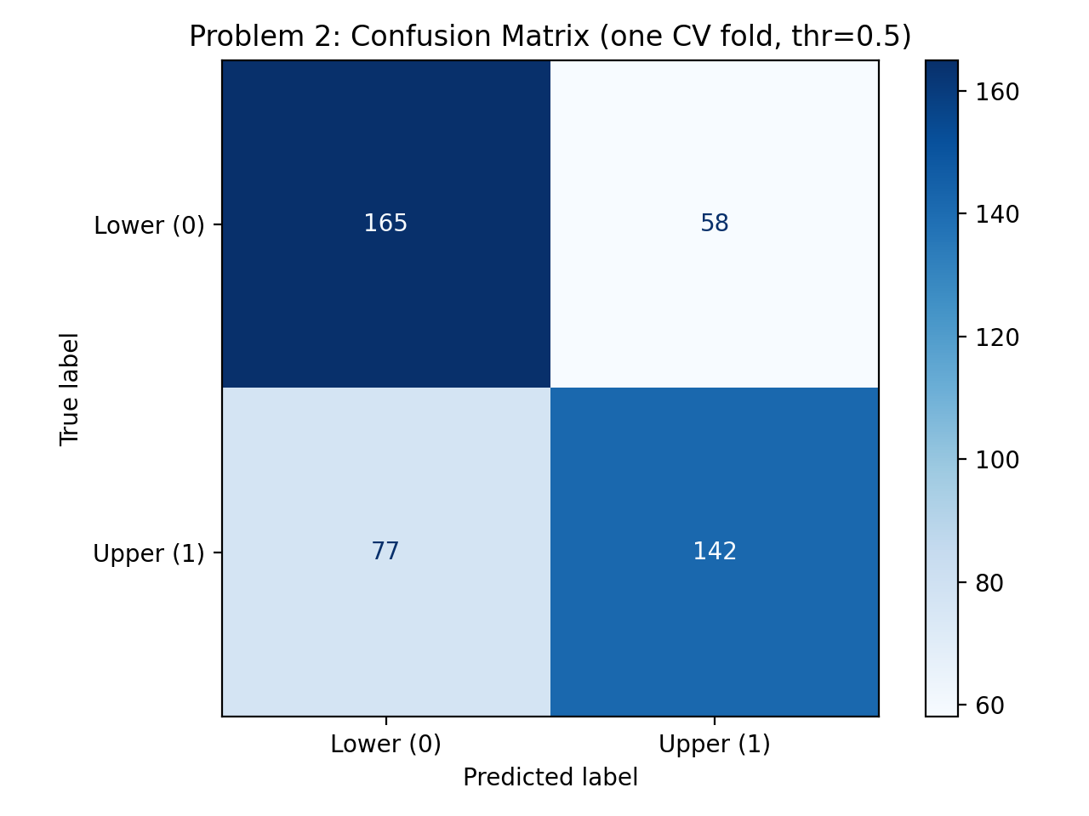
Figure 2 - Confusion Matrix
True Lower (0): 165 correct, 58 incorrect; True Upper (1): 142 correct, 77 incorrect. Color intensity indicates sample counts. The model performs slightly better on lower-level passages but confuses borderline texts with mixed lexical and syntactic complexity. Group-based folds make this matrix not directly comparable to the Problem 1 results.
Figure 2 presents the confusion matrix for the best classifier selected in Section 2C i.e. Logistic Regression trained on 768-dimensional BERT embeddings.
Evaluation was performed on one held-out validation fold (unseen during training). The model correctly identified 165 lower-level and 142 upper-level passages, achieving an overall accuracy of roughly 70 %. False positives (58 cases) arise when the model predicts “upper-level” for passages that are simpler. These are often texts containing rare or abstract vocabulary within otherwise straightforward syntax. False negatives (77 cases) occur primarily for short but semantically dense or metaphorical passages that the model underestimates in difficulty.

Relative to the Bag-of-Words classifier in Problem 1, this BERT-based model makes fewer purely lexical mistakes but still struggles with stylistic variation among authors. Because Problem 2 uses author-grouped folds (StratifiedGroupKFold) and dense contextual embeddings, its confusion matrix is not directly comparable to Problem 1’s, which was computed under random stratification using sparse BoW features. Nonetheless, the distribution of errors shows improved semantic discrimination and reduced over-reliance on word frequency patterns.
2E- Report Performance on Test Set via Leaderboard
The final BERT-based classifier achieved a cross-validated AUROC of 0.78 and a leaderboard test-set AUROC of 0.73.
Compared with the Bag-of-Words model from Problem 1 (CV ≈ 0.80, test ≈ 0.69), the BERT model provided more stable generalization across authors, indicating that contextualized semantic features capture reading difficulty more robustly than raw lexical frequencies.
Future improvements could include integrating readability metrics or fine-tuning BERT on educational corpora to better handle historical or archaic language that still confuses the classifier.
Overall, the BERT pipeline met expectations for Problem 2, balancing accuracy and generalization while demonstrating clear advancement beyond the baseline.

